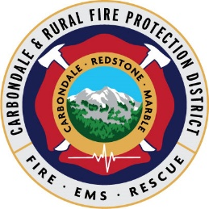

New Member Academy - Application & Membership Process

September: Application is submitted, reviewed for completeness, acknowledged via email

October: Interviews will be arranged– interviews are informal Q & A sessions

November: Selection notifications will be made via email

January: New Member Academy starts, second Monday of the month

New volunteers become probationary members for 6 months. During this time the probationary member must complete the mandatory New Member Academy and other probationary member requirements including monthly shift participation and completion of the New Member task book.

* The New Member Academy consists of the following courses: Colorado Mountain College (CMC) Emergency Medical Technician (EMT-B), Firefighter I Academy, Wildland Firefighter (S130/190) and department orientation.
* All probationary members are required to participate on shift 24 hours each month
* If the probationary member has a Colorado EMT or Colorado Firefighter certification upon joining, they will not need to complete that portion of the New Member Academy
* After successful completion of the 6-month probationary period and New Member Academy, review of the Probationary Member’s activity within the department will take place. This review will include overall department involvement, other training, shift participation, participation in department community events and task book completion.
* If the Probationary Member review is satisfactory, the Probationary Member may become a full Active Member. If the review is not satisfactory, probation may be extended for up to 3 months.
* Volunteers are issued all required safety equipment and personal protection clothing for their use.

The volunteer fire and emergency medical services are unique and require time and commitment.

The department provides 24-hour emergency response to a wide variety of critical situations, including medical emergencies, motor vehicle accidents, wildfires, structure fires, explosions, hazardous materials incidents, and miscellaneous public assistance requests.  In addition, the department operates active fire prevention, wildfire mitigation, emergency preparedness programs and community education.